LAB EXPERIMENT RECORD
Set 10: Survey Responses Analysis
Field | Details
Department | AIML
Course Code / Course Name | DSA0602 / Data Handling and Visualization
Experiment | Data Visualization using R
Name | B Mallika
Register Number | 192324234
Date | 06-10-2026
Day | Tuesday
Aim
To visualize survey responses using grouped and stacked bar charts, display the response data in a table, and prepare an interactive Tableau dashboard for exploring the survey results.
Dataset: Survey Responses
Survey ID | Question 1 | Question 2 | Question 3
1 | A | B | C
2 | B | A | D
3 | C | A | B
PROGRAM 1: Grouped Bar Chart of Question 1
Create a grouped bar chart to visualize the distribution of answers for Question 1. Label the chart elements.
# Dataset
survey_id <- c(1, 2, 3)
q1 <- c("A", "B", "C")
q2 <- c("B", "A", "A")
q3 <- c("C", "D", "B")
# Grouped Bar Chart
q1_count <- table(factor(q1, levels = c("A", "B", "C")))
barplot(q1_count,
beside = TRUE,
xlab = "Answer Option",
ylab = "Number of Responses",
main = "Distribution of Answers for Question 1",
col = c("#1f77b4", "#ff7f0e", "#2ca02c"),
legend.text = TRUE)
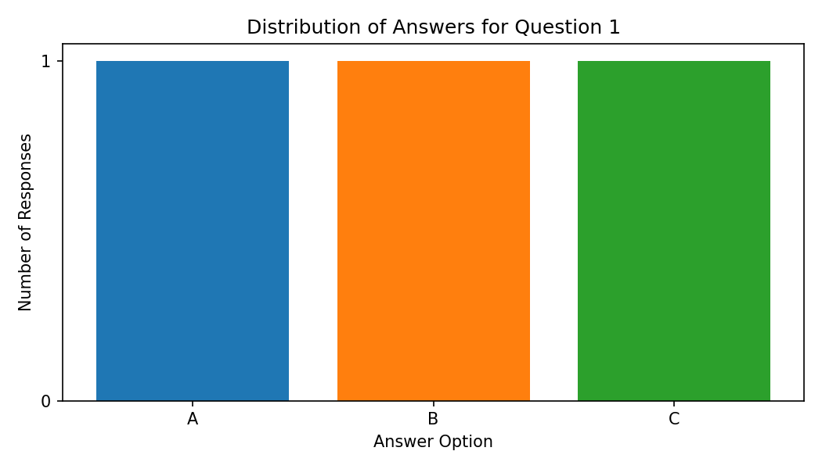
Output 1: Grouped Bar Chart of Question 1
Observation: Each of the answer options A, B and C was chosen by exactly one respondent for Question 1, so the answers are evenly distributed and no option is dominant.
PROGRAM 2: Stacked Bar Chart of All Questions
Generate a stacked bar chart to represent the overall distribution of responses for all three questions.
# Count of each option for every question
options <- c("A", "B", "C", "D")
counts <- rbind(
"Question 1" = table(factor(q1, levels = options)),
"Question 2" = table(factor(q2, levels = options)),
"Question 3" = table(factor(q3, levels = options))
)
# Stacked Bar Chart
barplot(t(counts),
beside = FALSE,
xlab = "Question",
ylab = "Number of Responses",
main = "Overall Distribution of Responses",
col = c("#1f77b4", "#ff7f0e", "#2ca02c", "#d62728"),
legend.text = paste("Option", options))
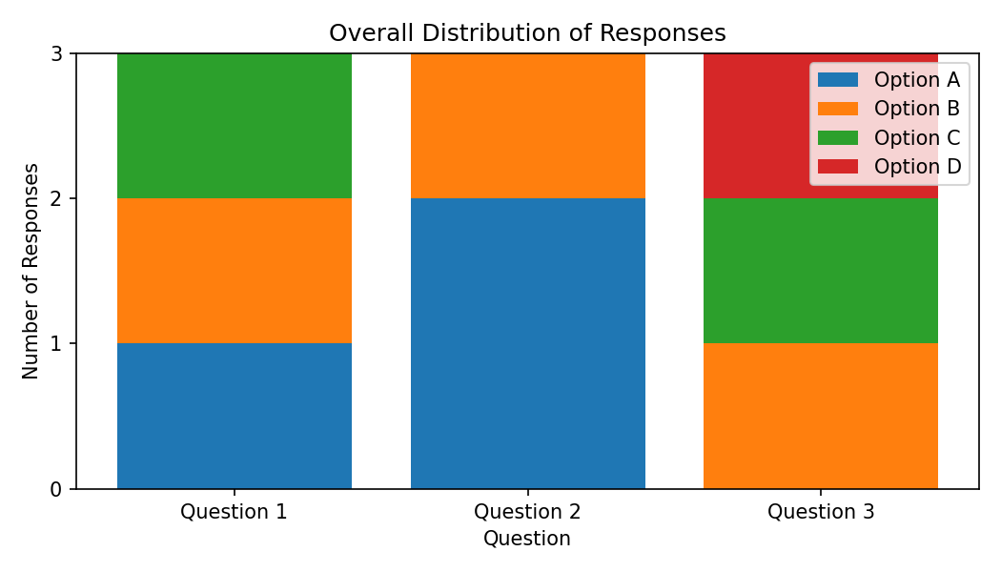
Output 2: Stacked Bar Chart of All Questions
Observation: Option A appears 3 times (once in Question 1 and twice in Question 2) and option B appears 3 times (once in each question). Option C appears 2 times and option D appears once (Question 3 only). Question 2 is dominated by option A.
PROGRAM 3: Survey Response Table
Build a table to show the survey response data for each survey. Label the table elements.
# Survey Response Table
survey_data <- data.frame(
"Survey ID" = survey_id,
"Question 1" = q1,
"Question 2" = q2,
"Question 3" = q3,
check.names = FALSE
)
print(survey_data)
Survey ID | Question 1 | Question 2 | Question 3
1 | A | B | C
2 | B | A | D
3 | C | A | B
Output 3: Survey Response Table
Observation: The table lists the answers given by each of the three surveys for Questions 1 to 3; every survey has one answer per question.
PROGRAM 4: Interactive Survey Dashboard
Develop a Tableau dashboard combining the grouped bar chart, stacked bar chart, and the table for interactive exploration of survey responses.
# Tableau Dashboard - Required Views
# 1. Import the Survey Responses dataset into Tableau and pivot
# Question 1-3 into "Question" and "Answer" fields.
# 2. Create a grouped bar chart: Answer (Columns) and
# COUNT(Survey ID) (Rows), filtered to Question 1.
# 3. Create a stacked bar chart: Question (Columns),
# COUNT(Survey ID) (Rows) and Answer on Color.
# 4. Create a table showing Survey ID against all answers.
# 5. Add all sheets to a dashboard, add a Question filter and
# enable "Use as Filter" on the charts.
# R view for the supplied data:
par(mfrow = c(1, 2))
barplot(q1_count, xlab = "Answer", ylab = "Responses", main = "Question 1")
barplot(t(counts), xlab = "Question", ylab = "Responses",
main = "All Questions", legend.text = options)
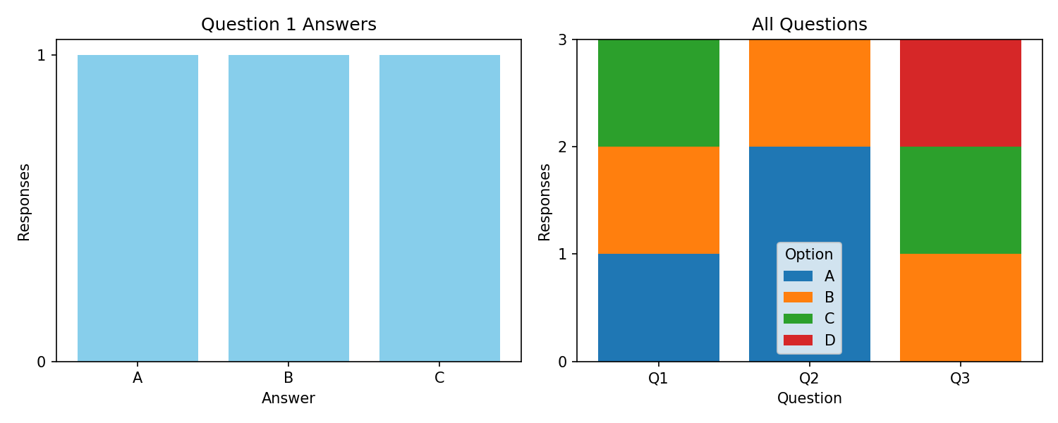
Output 4: Interactive Survey Dashboard
Observation: The dashboard combines the Question 1 answer distribution, the all-question stacked view and the response table. Clicking an option in the stacked bar highlights the matching survey rows in the table.
Set 10 Procedure
1. Create the Survey ID and Question 1 to 3 vectors from the given survey data.
2. Use table() and barplot() to draw the grouped bar chart for Question 1.
3. Build a count matrix for all questions and use barplot() with beside = FALSE for the stacked bar chart.
4. Use data.frame() to display the survey responses as a table.
5. Create the Tableau dashboard by combining the charts and the table and adding filters.
Set 10 Result
The survey responses were successfully visualized using grouped and stacked bar charts and displayed in a table. The interactive dashboard was designed in Tableau for exploring the responses.

LAB EXPERIMENT RECORD
Set 11: Product Category Analysis
Field | Details
Department | AIML
Course Code / Course Name | DSA0602 / Data Handling and Visualization
Experiment | Data Visualization using R
Aim
To analyze product category sales using a funnel chart and a pie chart, display the sales data in a table, and prepare an interactive Tableau dashboard.
Dataset: Product Categories
Category | Sales (in $)
Electronics | 50000
Clothing | 35000
Appliances | 40000
PROGRAM 1: Funnel Chart of Product Category Sales
Generate a funnel chart to analyze the sales conversion process for each product category. Label the stages and title the chart.
# Dataset
category <- c("Electronics", "Clothing", "Appliances")
sales <- c(50000, 35000, 40000)
# Sort categories from highest to lowest sales (funnel stages)
ord <- order(sales, decreasing = TRUE)
category <- category[ord]
sales <- sales[ord]
# Funnel Chart (centered horizontal bars)
plot(NULL, xlim = c(0, max(sales)), ylim = c(0.5, 3.5),
axes = FALSE, xlab = "", ylab = "",
main = "Sales Funnel by Product Category")
for (i in 1:3) {
left <- (max(sales) - sales[i]) / 2
rect(left, 4 - i - 0.4, left + sales[i], 4 - i + 0.4,
col = c("#1f77b4", "#ff7f0e", "#2ca02c")[i])
text(max(sales) / 2, 4 - i,
paste0(category[i], ": $", sales[i]), col = "white", font = 2)
}
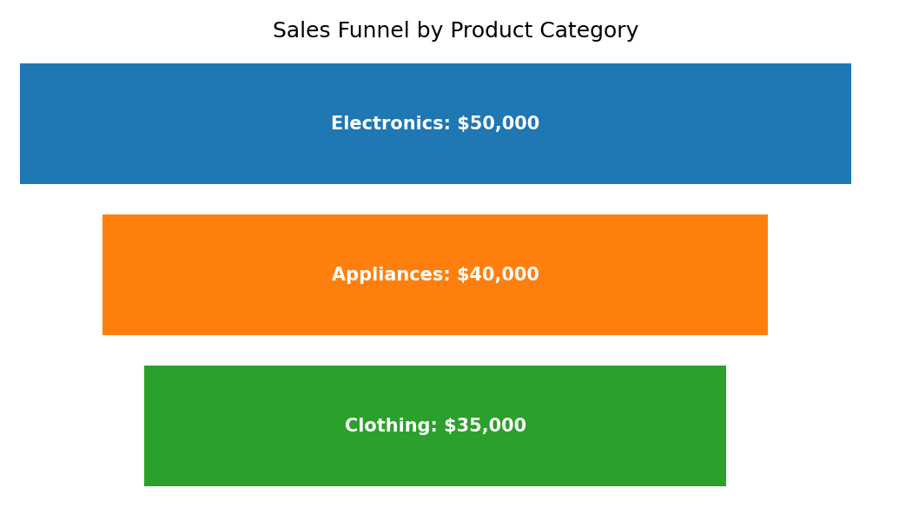
Output 1: Funnel Chart of Product Category Sales
Observation: Electronics is the widest stage with $50,000 (40% of total sales), followed by Appliances with $40,000 (32%) and Clothing with $35,000 (28%). The funnel narrows from Electronics to Clothing, showing the ranking of categories by sales.
Note: The dataset gives only total sales per category. A true conversion funnel (for example visits, carts and orders) requires stage-wise counts, so the categories are ranked as funnel stages.
PROGRAM 2: Product Category Sales Table
Build a table to display the sales data for each product category. Label the table elements.
# Product Category Sales Table
category_data <- data.frame(
Category = c("Electronics", "Clothing", "Appliances"),
"Sales (in $)" = c(50000, 35000, 40000),
check.names = FALSE
)
print(category_data)
sum(category_data$"Sales (in $)") # Total = 125000
Category | Sales (in $)
Electronics | 50000
Clothing | 35000
Appliances | 40000
Output 2: Product Category Sales Table
Observation: The table lists the sales of each category. Total sales across the three categories are $125,000, with Electronics contributing the most and Clothing the least.
PROGRAM 3: Interactive Product Category Dashboard
Develop a Tableau dashboard combining the pie chart, funnel chart, and the table for interactive exploration of product category data.
# Tableau Dashboard - Required Views
# 1. Import the Product Categories dataset into Tableau.
# 2. Pie chart: Category on Color, SUM(Sales) on Angle.
# 3. Funnel chart: bar chart of SUM(Sales) by Category, sorted in
# descending order, with the bars centered (dual axis / negative
# copy of Sales).
# 4. Table: Category and SUM(Sales).
# 5. Place all three sheets on one dashboard, add a Category filter
# and enable "Use as Filter" on the pie chart.
# R view for the supplied data:
par(mfrow = c(1, 2))
pie(sales, labels = paste0(category, " (",
round(sales / sum(sales) * 100, 1), "%)"),
main = "Sales Share")
barplot(sales, names.arg = category, main = "Sales by Category")
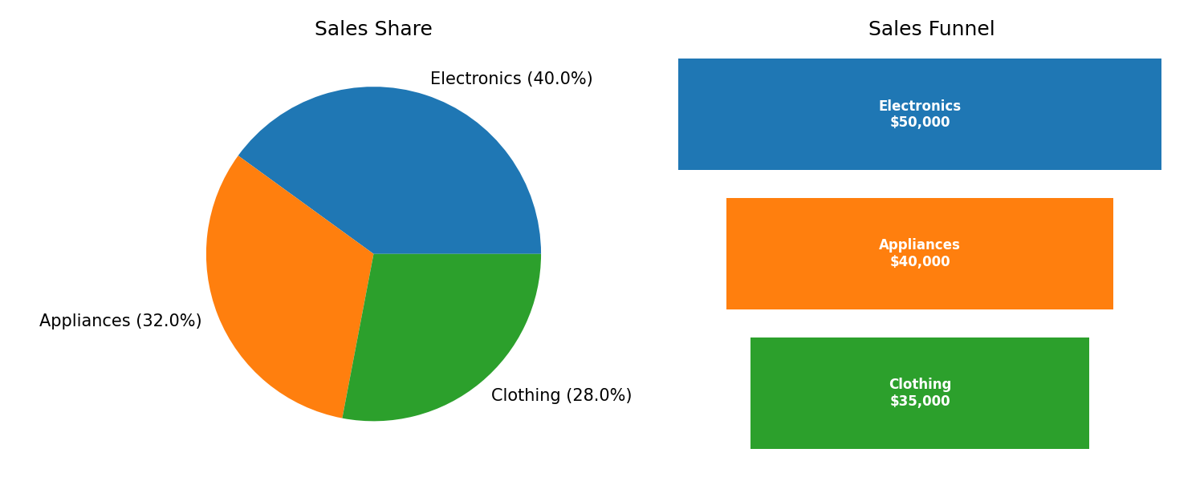
Output 3: Interactive Product Category Dashboard
Observation: The dashboard shows the sales share (pie), the category ranking (funnel) and the sales table together. Selecting a slice such as Electronics filters the funnel and the table to that category.
PROGRAM 4: Pie Chart of Sales by Category
Create a pie chart to represent the distribution of sales across product categories. Include labels.
# Pie Chart
pct <- round(sales / sum(sales) * 100, 1)
labels <- paste0(category, " (", pct, "%)")
pie(sales,
labels = labels,
col = c("#1f77b4", "#ff7f0e", "#2ca02c"),
main = "Sales Distribution by Product Category")
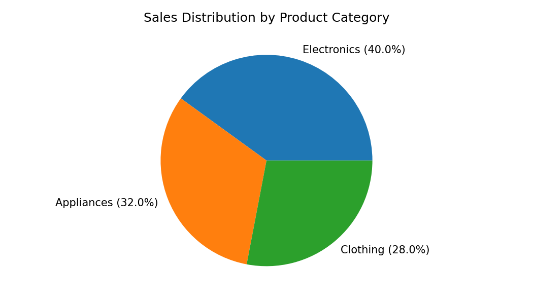
Output 4: Pie Chart of Sales by Category
Observation: Electronics holds the largest share of sales (40%), Appliances 32% and Clothing 28%. No single category dominates, but Electronics leads by $10,000 over Appliances.
Set 11 Procedure
1. Create the category and sales vectors from the given product category data.
2. Sort the sales values and draw the funnel chart using rect() and text() in base R.
3. Display the category sales in a data frame (table).
4. Use pie() with percentage labels to show the sales distribution.
5. Build the Tableau dashboard combining the pie chart, funnel chart and table with filters.
Set 11 Result
The product category sales were successfully represented using a funnel chart, table and pie chart, and the interactive dashboard was designed in Tableau. Electronics contributes the highest share (40%) of the total sales of $125,000.

LAB EXPERIMENT RECORD
Set 12: Website Traffic Analysis
Field | Details
Department | AIML
Course Code / Course Name | DSA0602 / Data Handling and Visualization
Experiment | Data Visualization using R
Aim
To analyze website traffic using line and bar charts, display the daily traffic data in a table, and prepare an interactive Tableau dashboard.
Dataset: Website Traffic
Date | Page Views | Click-through Rate
2023-01-01 | 1500 | 2.3%
2023-01-02 | 1600 | 2.7%
2023-01-03 | 1400 | 2.0%
PROGRAM 1: Line Chart of Daily Page Views
Create a line chart to visualize the trend in daily page views over time. Label the axes and title the chart.
# Dataset
date <- as.Date(c("2023-01-01", "2023-01-02", "2023-01-03"))
page_views <- c(1500, 1600, 1400)
ctr <- c(2.3, 2.7, 2.0)
# Line Chart
plot(date, page_views,
type = "o",
xlab = "Date",
ylab = "Page Views",
main = "Daily Page Views Trend")
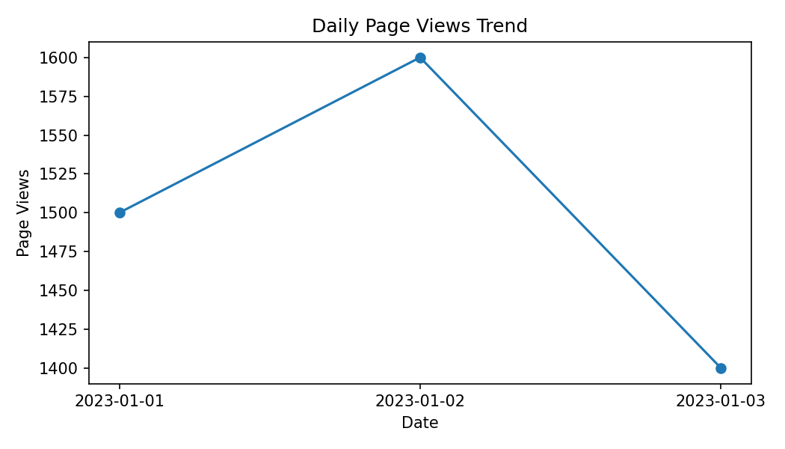
Output 1: Line Chart of Daily Page Views
Observation: Page views rise from 1500 on January 1 to a peak of 1600 on January 2 and then fall to 1400 on January 3, the lowest value of the period.
PROGRAM 2: Bar Chart of Top N Click-through Rates
Generate a bar chart showing the top N days with the highest click-through rates. Label the chart elements.
# Top N days
n <- 2
idx <- order(ctr, decreasing = TRUE)[1:n]
barplot(ctr[idx],
names.arg = format(date[idx], "%Y-%m-%d"),
xlab = "Date",
ylab = "Click-through Rate (%)",
main = "Top 2 Days by Click-through Rate",
col = "skyblue")
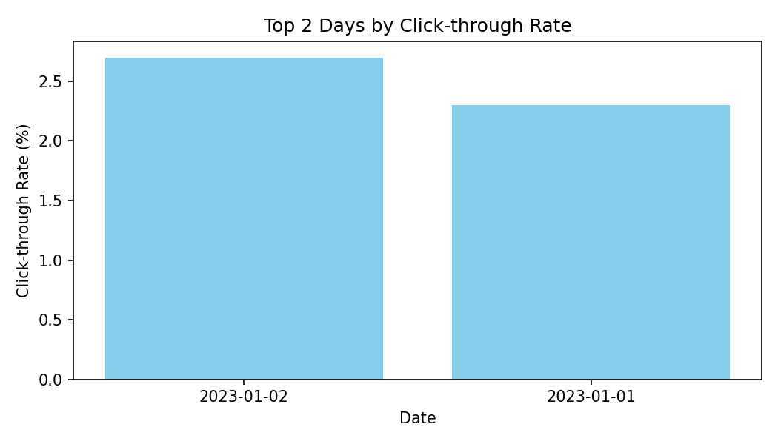
Output 2: Bar Chart of Top N Click-through Rates
Observation: For N = 2, January 2 has the highest click-through rate (2.7%), followed by January 1 (2.3%). January 3 has the lowest rate (2.0%) and is excluded.
PROGRAM 3: Website Traffic Table
Build a table to show the website traffic data for each day. Label the table elements.
# Website Traffic Table
traffic <- data.frame(
Date = date,
"Page Views" = page_views,
"Click-through Rate (%)" = ctr,
check.names = FALSE
)
print(traffic)
Date | Page Views | Click-through Rate
2023-01-01 | 1500 | 2.3%
2023-01-02 | 1600 | 2.7%
2023-01-03 | 1400 | 2.0%
Output 3: Website Traffic Table
Observation: The table shows the page views and click-through rate for each day. January 2 has both the highest page views (1600) and the highest click-through rate (2.7%), while January 3 has the lowest of both (1400 and 2.0%).
PROGRAM 4: Interactive Website Traffic Dashboard
Develop a Tableau dashboard combining the line chart, bar chart, and the table for interactive exploration of website traffic data.
# Tableau Dashboard - Required Views
# 1. Import the Website Traffic dataset into Tableau.
# 2. Line chart: Date (Columns) and SUM(Page Views) (Rows).
# 3. Bar chart: Date (Columns) and AVG(Click-through Rate) (Rows),
# sorted in descending order (Top N filter on Date).
# 4. Table: Date, Page Views and Click-through Rate.
# 5. Add all sheets to one dashboard, add a Date filter and
# enable "Use as Filter" on the line chart.
# R view for the supplied data:
par(mfrow = c(1, 2))
plot(date, page_views, type = "o", xlab = "Date",
ylab = "Page Views", main = "Daily Page Views")
barplot(ctr[idx], names.arg = format(date[idx], "%Y-%m-%d"),
xlab = "Date", ylab = "CTR (%)", main = "Top 2 Days by CTR",
col = "skyblue")
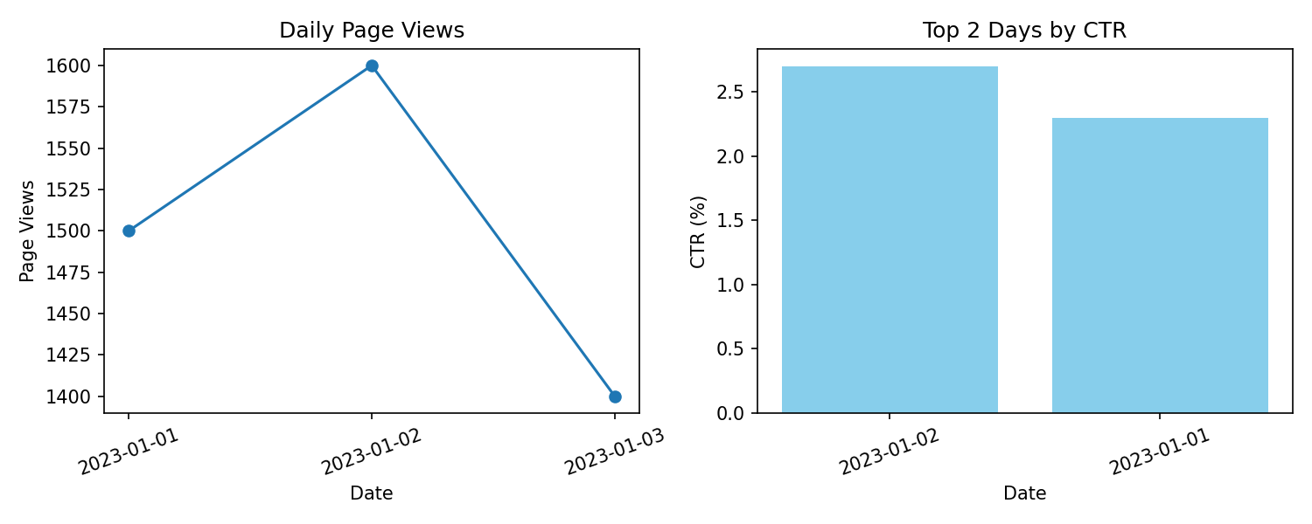
Output 4: Interactive Website Traffic Dashboard
Observation: The dashboard links the page-view trend, the top click-through-rate days and the traffic table. Selecting a date highlights the same day in every view, showing that the best day (January 2) combined high traffic with a high click-through rate.
Set 12 Procedure
1. Create the Date, Page Views and Click-through Rate vectors from the given traffic data.
2. Use plot() with type = "o" to draw the daily page-view line chart.
3. Sort the click-through rates with order() and use barplot() for the top N days.
4. Use data.frame() to display the website traffic table.
5. Build the Tableau dashboard combining the line chart, bar chart and table with filters.
Set 12 Result
The website traffic data was successfully visualized using a line chart, a top-N bar chart and a table, and the interactive dashboard was designed in Tableau. January 2 was the best-performing day with 1600 page views and a 2.7% click-through rate.

